

April 15, 2026
WINNING TESTIMONIALS: BUILD YOUR REPUTATION WITH PROOF OF PERFORMANCE
SIMPLE SCRIPT BUILDER TO ASK FOR REVIEWS
*
Most clients are happy to provide a testimonial. They just need a simple, easy reminder. Use the template below to write your own ask script. Replace the parenthesis with details specific to your business. Tip: Send this ask within a week of completing a project, when the experience is fresh and the client's satisfaction is highest.
Hi [Client Name],
I really enjoyed working on (describe the project or contract) with you and your team. I'm proud of the results we delivered, especially (specific outcome: on time, under budget, high quality, etc.).
Would you be willing to share a short note about your experience? Just two or three sentences is plenty, but feel free to write more. I'd love to use it to share about our company’s service delivery. You can reply to this email, or I can send you a short template to make it easy.
Thank you so much. I appreciate your time and support!
(Your Name and Business)

Government buyers research vendors before making contact. This checklist shows you where your reputation is visible, credible, and working, and where you can improve.
Online Presence | Proof of Performance | Habits and Systems
- LinkedIn company page with recent activity | - At least three written client testimonials | - Regular updates to marketing with new testimonials
- Active, up-to-date Google Business profile and other online profiles | - Capability statement with strong past performance or client quotes | - Process for requesting testimonials after project completion
- Yelp listing or industry-specific directory profile | - At least one testimonial with a specific outcome or result | - Routine monitoring of online reviews
- Website testimonials, past performance case studies, and/or reviews page | - Documented case studies or success stories published or ready to share in marketing or proposals | - Consistent project outcomes tracking (time, cost, quality, size of facility, quantity of product, scope, metrics, results, etc.) to use to document past performance
- Current, professional social media profiles | - At least one recent Google, LinkedIn, or Yelp review or recommendation | - Email template, QR code or simplified method of asking for reviews and testimonials

YOUR REPUTATION AUDIT
*

Step 1 — The Client and Challenge
Who was the client? | Client type, government agency, and/or industry? | What problem or need did they have? | How did you solve this? | Details, scope, size, facts, quantities, etc.
Step 2 — Your Approach
What is your approach to this type of project? What systems and processes were used? |  | What made your approach different or effective? | How did you adapt your approach to this project?
Step 3 — The Results
What was the outcome? Use specifics where possible. | Measurable results (e.g., 10,000 sq, ft. facility serviced, upgraded 425 computers, delivered two weeks early, provided product at 15% less than past contract)? |  | Other factors such as quality improvements, problem-solving, accessibility, eco-friendly features, safety record, uptime, etc.
Step 4 — Client Feedback
If you have a testimonial from this client, capture the key phrase here.
Step 5 — The Visuals
What visual assets do you have or could you obtain to support this story? Examples include before/after photos, site maps, floor plans, org charts, product photos, screenshots, data visualizations, and team photos on-site.

Your Best Project Story
Agency buyers remember stories. Facts are important, but statewide contract buyers need to hear narratives of strong performance, with evidence of capacity. Use the five-step framework below to turn one of your best projects into a compelling success story. Use this on your website as a case study and in proposals, emails, and other materials.

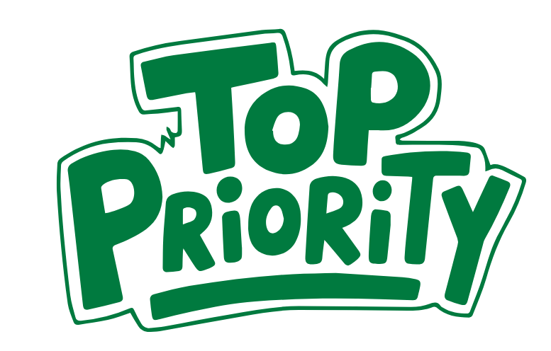
WHAT ARE YOUR TOP REVIEW AND TESTIMONIAL GOALS FOR 2026?

