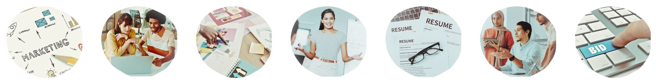

November 19, 2025 — Materials That Market: High-Impact Templates and Tools Workshop
BRANDING FOR BUSINESS DEVELOPMENT GROWTH
What qualities do you want to communicate to potential clients about your company? Check all that apply.
Reliable Competitive Pricing Strong Past Performance Safety/Compliance
High Quality Work Accurate Skilled Workforce Strong Quality Control
Consistent Follow Thr Responsive Strong Operations Highly Qualified
Hight Integrity Professional Easy to Work With Efficient Delivery
Diverse/Inclusive Innovative Clear Communication Strong Mission/Purpose
_________________ _________________ _________________ _________________

*
WHAT IMPRESSION ARE YOU MAKING?
Find your last proposal submission and copies of your capability statement and other materials. Let’s review your branding. Fill out this checklist. Write notes and brainstorm ideas for how to improve your brand.
- We have a clean, high-quality logo that is easy to read/recognize. We use it on all our materials.
Notes and ideas

- We use our preferred brand colors in all company materials. Our marketing creates the right impression.
Notes and ideas

- Our photos are clear and match a professional style. Our photos help convey our marketing messages. We have high-quality images of company staff, projects, job sites, and/or products.
Notes and ideas

- Fonts, style, and look are consistent and match the logo. Our business development materials reinforce our branding.
Notes and ideas

- We have business cards, flyers, uniforms, vehicles, signs, or other materials that echo our brand.
Notes and ideas

*
BRANDING GOALS

Your Name Your Company Name

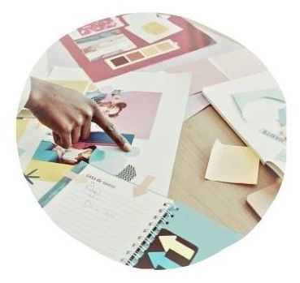
Visual Branding, Logo, Company Colors
Completed Needs Improvement
Do Not Have

REMEMBER: A strong brand helps create a clear and consistent impression. Templates help maintain consistency and speed up the bidding process and business development efforts.

Handouts for Events and Meetings (Printed folders, brochures, flyers, bios, etc.)
Completed Needs Improvement
Do Not Have

Bonus Branding (Uniforms, vehicles, signage, etc.)
Completed Needs Improvement
Do Not Have

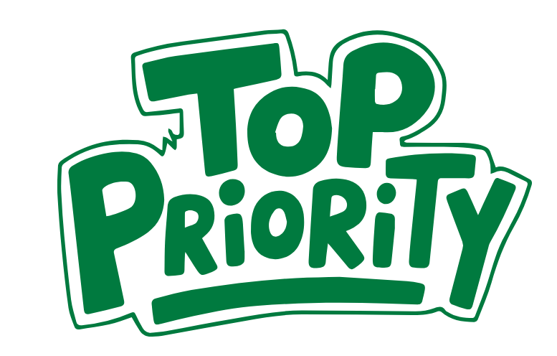
WHAT IS YOUR TOP TEMPLATE OR BRANDING GOAL FOR 2026?
*

Next Steps for Templates and Tools
On the previous page, you clarified some brand goals and inventoried existing materials. Let’s write 2026 goals for your brand, templates, and tools. Circle “Completed,” “Needs Improvement,” or “Do Not Have” in each box for your materials. Below this, write business development goals for the following year. Example goals may include:
- “By February 1, 2026, we will have a new capability statement finished”
- “Create org chart, bios and resumes for all staff members for our proposals by December 31, 2025.”
- “We will design new logo and upload to website by March 1, 2026.”
- “Our firm will order signage for vehicles by May next year.”

Team Resumes
Completed Needs Improvement
Do Not Have

Proposal Templates
(Past Performance, Etc.)
Completed Needs Improvement
Do Not Have

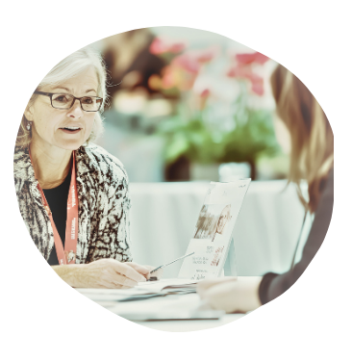
Pitch Deck
Completed Needs Improvement
Do Not Have

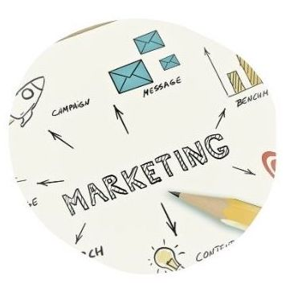
Capability Statement (Updated with your most recent past performance)
Completed Needs Improvement
Do Not Have


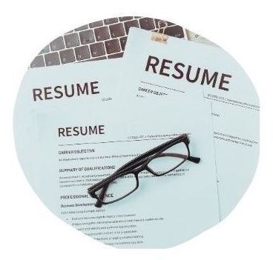
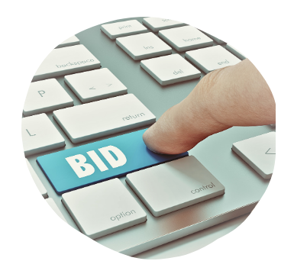
Statement of Qualifications
Completed Needs Improvement
Do Not Have/Not Needed



